Walk-a-Thon 2019
Our original walkathon was scheduled for April 12, 2019. Unfortunately, it was postponed to May 14, 2019, due to medical and technical difficulties. Our walk was nice, serene, and a bit wet. When it started down-pouring, we journeyed back to the car and went to drop off clothes for our annual Salvation Army clothes drive.
Thank you for your support!

17 Old York Rd. Ringoes, N.J. 08551
(908)938-5286 www.christianacademy-ourhope.org officeislandofhope7@gmail.com Visit us on Facebook too.
HOPE is a K4 thru 12th Grade non-denominational, non-profit, traditional Christian school located in Ringoes, N.J. Call us for more information at 908-938-5286, as we serve to help provide students with a Hope and a Future. (Jeremiah 29:11)

(Our) HOPE Christian Academy
Cookbook 2019
Homemade Goodies from our Kitchens to Yours

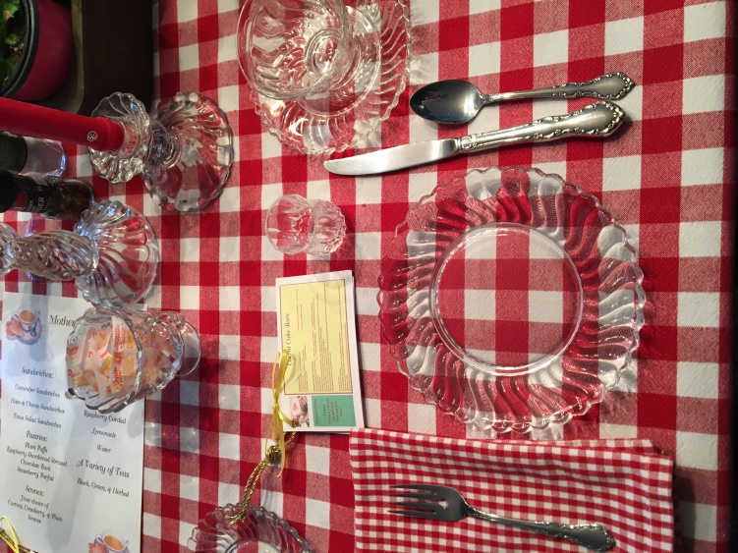
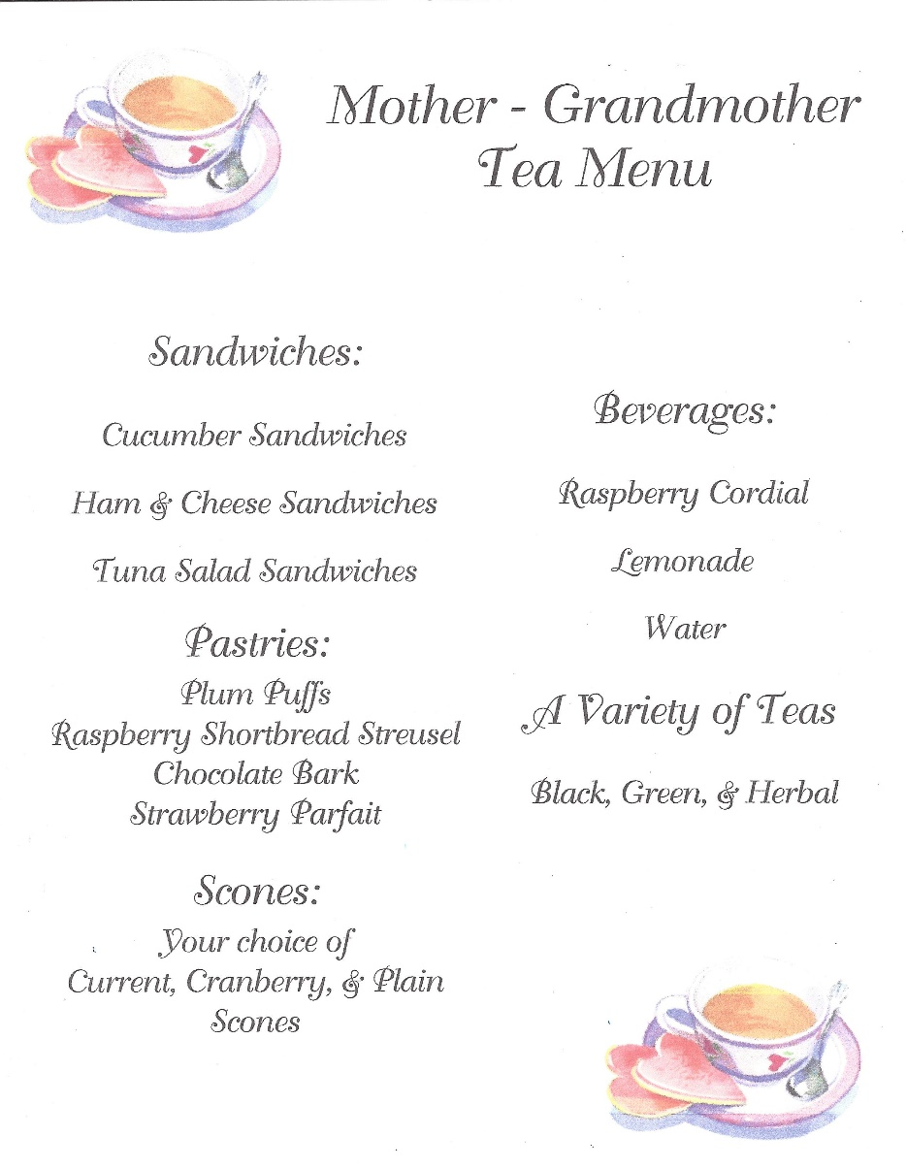

800.746.7748
Or visit us on Facebook too @shoprite.supermarket

MAIN STREET BAGELS
John Puckett
26 Main St
Flemington, NJ 08822
908.237.4688

Anne says: “It’s not what the world holds for you. It’s what you bring to it.”

Traditional Chex Party Mix

Ingredients:

½ cup (1 stick) of butter or margarine
1 ¼ tsp. seasoned salt
4½ tsp. Worcestershire sauce
2 2/3 cu. of Corn Chex cereal
2 2/3 cu. of Rice Chex cereal
2 2/3 cu. of Wheat Chex cereal
1 cu. of salted mixed nuts

Directions
Preheat oven to 250 degrees. Heat butter in large shallow roasting pan (about 15x10x2 inches) in oven until fully melted. Remove. Stir in seasoned salt and Worcestershire sauce. Add Chex and nuts. Mix until all pieces are coated. Heat in oven for one hour. Stir every fifteen minutes. Spread onto absorbent paper to cool.

Strawberry Shortbread Bars
CRUST:
1 ½ cu. UNBLEACHED all-purpose flour (bleached flour toughens bakes goods 1 tbs. milk
1 tsp. baking powder 1 large egg slightly beaten
½ cu. cold unsalted butter 12 oz. strawberry preserves
TOPPING:
1 large egg ½ cu. Sugar 1 tsp. vanilla extract
2 tbs. melted unsalted butter 2 cu. Coconut
CRUST:
Heat oven to 350 degrees Bake time: 45 minutes
Spray a 9x13” baking pan or dish with cooking spray. Mix flour, baking powder in a medium mixing bowl. Cut in blender with a pastry cutter until mixture resembles coarse crumbs. Add egg and milk; stir to combine. Press mixture own very firmly into bottom of prepared pan with a fork or your hands. Spread strawberry preserves on top of crust layer to within ¼ to ½ inch of border.
TOPPING:
Beat egg with a fork. Stir in sugar, vanilla, butter, and coconut. This is kind of like a macaroon layer. Dollop topping over top of preserves covering surface entirely. Bake for 45 minutes or until lightly browned and preserves are set. Cool completely before serving.
Anne says: “It’s been my experience that you can nearly always enjoy things if you make up your mind firmly that you will.”

Anne of Green Gables Raspberry Cordial
Marilla says: “There’s a bottle half full of Raspberry Cordial that was left over from the church social the other night. It’s on the second shelf of the sitting-room closet, and you and Diana can have it if you like, and a cookie to eat with it along in the afternoon.”
Recipe courtesy of anneofgreengables.com
INGREDIENTS:
48 oz. raspberries, fresh or frozen (4 pints) 3 cu. sugar
1/3 cu. Fresh lemon juice 12 cu. Water
DIRECTIONS:
Clean and rinse the raspberries before putting them in a very large bowl. Pour lemon juice over the berries. Use a large spoon to stir the juice into the berries. On the stovetop, heat 12 cu. of water and 3 cu. sugar to a boil. Stir till the sugar dissolves. Remove from heat. Pour the boiling water over the raspberries. Allow the water to cool for 1-2 hours to room temperature. Cover the bowl with plastic wrap or a towel that you do not mind staining. Place in the refrigerator to steep for 24 hours. Pour the cordial through a fine mesh sieve to strain. Push gently on the solids with the back of a spoon, if you wish, to extract more juice. This will produce a slightly cloudy effect in the cordial, will settle at the bottom of the storage bottle, but it will not change the flavor. If you would prefer a clearer cordial, do not press down on the solids—just strain them. To serve, mix 1 part cordial with 1 part water or seltzer water. If you prefer a less sweet drink, dilute the cordial to taste- Recommended. Serve cold.

Hionis Greenhouses
4 Coddington Rd.,
Whitehouse Station, NJ 08889
908.534.7710
Find us on Facebook too, or visit us online at: www.hionisgreenhouses.com

Full Service Insurance Center

Personal | Business Coverage
* homeowners | * contractors
* automobile | * business owners’ policies
* umbrella | * workers’ compensation
* life
* health

Gilbert says: “There would never be anyone for me but you.”

Carrot Cake Bars
INGREDIENTS:
1 cu. melted butter 1 ¾ cu. brown sugar 1 tbs. vanilla extract
2 large eggs 1 large egg yolk
2 cu. grated carrots (about 3 carrots) 2 ¼ cu. all-purpose flour
2 tsp. cinnamon ½ tsp. salt

DIRECTIONS:
Preheat oven: 350 degrees Bake Time: 28-32 minutes
Line a 9x13” baking pan with aluminum foil and lightly grease. In a large bowl, stir together the melted butter and brown sugar. Stir in the vanilla, eggs, egg yolk, and grated carrots. Gently fold in the flour, cinnamon, and salt. Pour the batter into the prepared pan and bake for 28-32 minutes or until the top looks set and the edges are just starting to pull away from the pan. Allow to cool.
Carrot Cake Icing
INGREDIENTS:
1/3 cu. softened unsalted butter
6 oz. softened cream cheese 1 tsp. vanilla extract ¼ tsp. salt
1 ½ - 2 cu. powdered sugar ¼ cu. chopped walnuts (optional)

DIRECTIONS:
Beat together the butter and cream cheese in a large bowl. Add the vanilla extract and salt, then carefully beat in the powdered sugar until you get to your desired sweetness level. Frost the cooled bars and sprinkle with chopped walnuts (optional).
Anne says: “Anne Shirley plain old unromantic Anne Shirley.”
Gilbert says: “I hope you keep on dreaming.”

Chocolate Bark
Makes 2 lbs. of candy.
INGREDIENTS:
1 lbs. (16 oz.) good quality dark chocolate
12 oz. good quality white chocolate 1 ½ tsp. peppermint extract
10 6-inch candy canes
DIRECTIONS:
Cover a 13x9” cookie sheet with parchment or waxed paper. Slowly melt 1 lb. dark chocolate in a double boiler, being careful to not burn the chocolate. Remove from heat and add ¾ tsp. of peppermint extract to the dark chocolate and combine. Spread melted chocolate on the cookie sheet and place in the refrigerator for 10 minutes. Meanwhile, melt the white chocolate in a double boiler, being extra careful not to burn the white chocolate. Remove from heat and stir in remaining ¾ tsp. of peppermint extract. Remove cookie sheet from refrigerator and swirl with the melted white chocolate. Sprinkle with peppermint candles and place back in the refrigerator. Cool for at least 1 hour, deepest areas of chocolate should be solid before removing from refrigerator.
Anne says: “True friends are always together in spirit.”

The Fudge Shoppe
a family owned company since 1961
908.782.7123
www.thefudgeshoppe.com

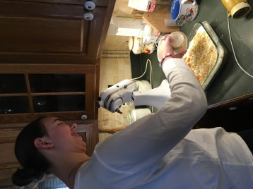 Carrot Cake Bars

West Amwell Mason Supply
Mike Triola
609.397.3373
mike@wamsnj.com

Anne of Green Gable Tea Plum Puffs
Recipe courtesy of anneofgreengables.com

INGREDIENTS: Makes 8 pints
1 Sheet of frozen puff pastry thawed
- Cup of Plum preserves
- Plums in 16 slices (each quarter quartered)
- Egg beaten for glaze
Brown sugar, for sprinkling on top

DIRECTIONS:
Spread out the puff pastry, and cut into 8 equal squares. Spread the plum preserves onto the pastry, the place two slices of plum onto half of each square. Fold one corner over, leaving about 1/2″ of the bottom layer showing. Fold the bottom corner up over the top, and seal with egg. Do the same with each Plum Puff, then brush the top of the pastries with the beaten egg. Sprinkle with a pinch of brown sugar.
Line a baking sheet with either parchment paper or a silpat. Arrange the pastries on the prepared baking sheet, and bake at 375F for 15 minutes. Let cool to at least room temperature before serving.
Anne of Green Gables Plum Puffs
Williamsburg Orange Cake from
Betty Crocker’s Cookbook

INGREDIENTS:
2 ¾ c. Gold Medal Flour 1 ½ c. Sugar
1 ½ tsp. baking soda ¾ tsp. salt
1 ½ c. Buttermilk
½ c. Butter softened ¼ c. Shortening
3 eggs 1 ½ tsp. vanilla
1 c. Golden raisins 1 tbs. grated orange peel

DIRECTIONS: Preheat oven to 350 degrees
Grease and flour baking pan 13x9x2” or 2 9”, or 3 8” round layer pans. Measure all ingredients in large mixer bowl. Blend at low speed, scraping constantly for ½ min. Beat at high speed 3 minutes scrapping occasionally. Pour into pans.

Bake: Oblong 40-50 min.; layers 30-35 min., or until wooden pick comes out clean from cake center. Cool and set aside. Make frosting, and ice cake accordingly.
Williamsburg Butter Frosting
For oblong cake or two 9-inch layers:
1/3 c. soft butter or margarine
3 c. confectioners’ sugar
3 to 4 tbs. orange juice
2 tsp. grated orange peel

For three 8-inch layer:
½ c. soft butter or margarine
4 ½ c. confectioners’ sugar
4 to 5 tbs. orange juice
1 tbs. grated orange peel
Lend butter and sugar. Stir in orange juice and orange peel; beat until smooth.

Anne says: “Plum Puffs won’t minister to a mind diseased in a world that’s crumbled to pieces.”

Oven Scones
Hymes, Angela. The Pleasures of Afternoon Tea. Los Angeles: HPBOOKS, 1987

INGREDIENTS:
2 cu. Self-rising flour 1 tbs. baking powder pinch of salt
2 tbs. cold butter in small pieces 1 egg, lightly beaten
5 tbs. milk, plus a little bit for brushing on scones 1 tsp. sugar
(Add ½ cu. – 1 cu. currants or craisins)

DIRECTIONS:
Preheat oven: 450 degrees. Bake time: 8-10 minutes
Very lightly grease a large baking sheet; set aside. Sift flour, baking powder, sugar, and salt into a large bowl. With your fingers, rub in butter until mixture is crumbly. Make a well in center of mixture; add egg and milk; mix with a fork to make a dough that barely holds together. (You may need to press dough together with your hands.) Turn onto a floured surface and knead lightly just until smooth. Roll out with a floured rolling pin or pat with your hands to make a round about ¾ inches thick. Cut into rounds with a 2” fluted or plain cookie cutter. Arrange 1 to ½ inches apart on baking sheet; brush tops lightly with milk. Bake 8-10 minutes or until well risen and golden. Transfer to a wire rack and cool 5 minutes. Split and serve warm with butter. Makes about 12 scones.

What you can expect
- Analysis of your complete insurance needs.
- We design a responsible protection program for you.
- We select the company or companies best suited to your situation.
- We present you with a competitively priced proposal.
- We move quickly to get fair, prompt settlement of your claims.We periodically review the adequacy of your insurance program.

Anne says: “Tomorrow is always fresh with no mistakes in it.”
Chick-Fil-A Lemonade
Prep Time: 5 Minutes Total Time: 5 Minutes
Servings: 6

INGREDIENTS:
1 ½ cu. lemon juice from freshly squeezed Sunkist lemons
1 cu. pure cane sugar
5 1/3 cu. filtered water

DIRECTIONS:
Add the lemon juice to a large pitcher. Add the sugar and whisk until dissolved. Add the water and whisk again. Refrigerate until chilled and serve over ice.

V & M Development Group, LLC
William Vogt
(610) 330-9800
www.vmdevelopmentgroup.com

Anne says: “One can dream so much better in a room where there are pretty things.”
Strawberry Parfait
Recipe courtesy of anneofgreengables.com
Prep Time: 20 min. Total Time: 20 min. Serves: 4 people
INGREDIENTS:
10 strawberries 4 plastic cups 1 cu. non-fat yogurt
2 tbs. brown sugar Whipped cream
DIRECTIONS:
Slice about 6 strawberries into bite-sized pieces. Layer the following ingredients into the plastic cups: 1 spoon full of yogurt, a few sliced strawberries, and a sprinkle of brown sugar. Top with whipped cream and 1 whole strawberry. Repeat this layering for the next 3 plastic cups. You may also add granola, nuts, and other fruit if you desire. Best served immediately; enjoy!

CHRISTMAS AROUND THE WORLD
IRELAND Germany Italy

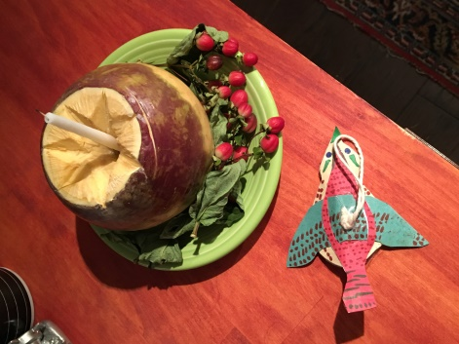

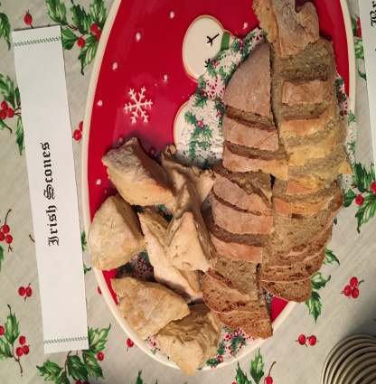
Soda Scones
Recipe taken from World Book, Christmas Around the World: Christmas in Ireland. Chicago: World Book, Inc., 1996.
INGREDIENTS:
3 cu. flour 1 tsp. cream of tartar 1 cu. buttermilk
1 tsp. salt 1 tsp. baking soda
DIRECTIONS:
Preheat: 400 degrees Bake time: app. 15 min.
Stir together the flour, cream of tartar, salt, and baking soda and mix lightly with the hands. Make a hollow in the center and add enough buttermilk to make a soft dough. Turn onto a floured board and knead quickly and lightly until the dough is free from cracks. Roll out into a circle about ½” thick. Cut into wedges (as if cutting a pie. Place on a greased and floured baking sheet and bake at 400 degrees for approximately 15 minutes.

1980 Route 206
Belle Mead, NJ 08502
908.428.4309
Find us on Facebook,
or visit us at www.bloomsbellemead.com

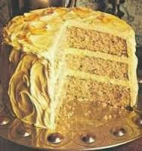
Williamsburg Orange Cake

Zuegner and Byrne, CPA’s
Timothy Byrne
(908)788-3700

gERMANY
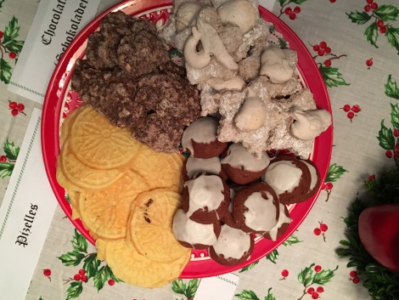
Cinnamon Stars
Recipe from World Book, Christmas Around the World: Christmas in Today’s Germany. Chicago: World Book, Inc., 1993.
INGREDIENTS:
2 cups powdered sugar 5 egg whites dash of salt
2 tsp. ground cinnamon 1 tsp. grated lemon zest
1 lb. ground unblanched almonds powdered sugar
DIRECTIONS:
Preheat oven: 300 degrees. Bake Time: 20 min.
Sift sugar; set aside. In a large bowl, beat egg whites and salt until stiff but not dry. Continue beating while adding sifted sugar, cinnamon, and lemon zest. Set aside 1/3 of the mixture. Fold almonds into the remaining batter.
Dust a pastry board with powdered sugar. With your fingers, press dough to 1/3” thickness. Do not use a rolling pin. If dough is sticky, dust your palms with powdered sugar. Cut dough with a star-shaped cookie cutter. Glaze with reserved egg mixture. Bake on a greased cookie sheet for 20 minutes. Makes about 4 dozen cookies.

Schokoladenmakronen (Chocolate Macaroons)
Recipe from World Book, Christmas Around the World: Christmas in Today’s Germany. Chicago: World Book, Inc., 1993.
INGREDIENTS:
4 egg whites ½ cu. sugar 2 cu. finely chopped almonds
5 squares unsweetened chocolate, finely grated
3 tbs. water ¼ tsp. ground cinnamon
dash each: ground allspice, cardamom, and nutmeg
DIRECTIONS:
Preheat Oven: 300 degrees Bake time: 20-25 min.
In a large bowl, beat egg whites until stiff. While still beating, gradually add sugar. Fold in almonds, chocolate, water, and spices. Drop mixture by teaspoonfuls onto waxed-paper-lined cookie sheets. Bake for 20 to 25 minutes. Cool on racks. Store cookies in a tightly sealed container. Makes about 3 dozen cookies.

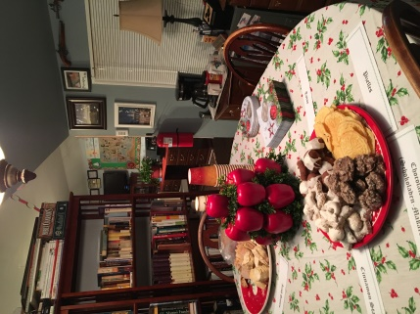
ITALY
Totos
INGREDIENTS:
3 ½ cu. sugar 2 cu. Crisco 6 eggs 2 cu. milk 1 cu. honey
1 tsp. vanilla 3 tsp. lemon juice 8 cu. flour 2 cu. cocoa
1 tsp. cinnamon 1 tsp. cloves 1 tsp. allspice
1 tsp. nutmeg 1 tsp. ginger 13 tsp. baking powder
1 lb. chopped walnuts *To make less, halve each ingredient.
DIRECTIONS:
Preheat oven: 350 degrees Bake Time: 12 min.
Mix together sugar, Crisco, eggs, milk, honey, vanilla, and lemon juice. When thoroughly mixed, add dry ingredients one at a time and mix completely. If dough is sticky, add a little flour. Take dough a spoonful at a time, roll into a ball. Place on cookie sheet. Bake for 12 minutes. Set aside and cool completely.
ICING INGREDIENTS:
1 cu. powdered sugar 1 tsp. vanilla 2 tbs. milk
ICING DIRECTIONS:
Mix ingredients together until thick, but still slightly runny. Place a dollop of icing on each of the cooled cookies. Allow to set for 15 minutes. Enjoy!
Italian Pizzelle
INGREDIENTS:
3 eggs, beaten ¾ cu. sugar ¾ cu. butter or margarine, melted
¾ -1 cu. flour 1 tsp. baking powder 2 tsp. anise extract
1 tsp. vanilla
DIRECTIONS:
Add and beat ingredients together in order listed (use the smaller amount of flour of thinner pizzelle.) Batter should be thick but flow from a spoon. Place about 1 tablespoon of batter in center of both sections of preheated grid on Pizzelle Baker. Close lid. Allow to cook until steaming stops- about 45 to 60 seconds. Remove with fork. Allow to cool on wire rack or towels. (While hot, they may be rolled into a cylinder or shaped into a cone.) Dust with confectioners’ sugar. Store in an airtight container. Makes 2 dozen.

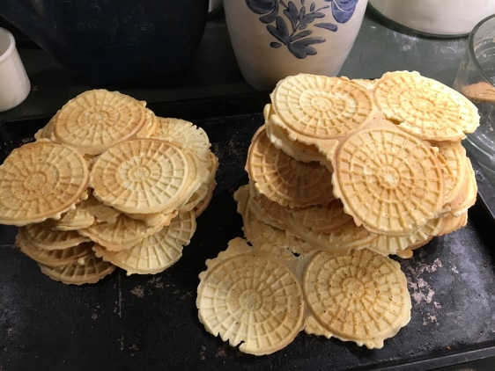
Chommie’s Rice Pudding
Recipe courtesy of Lorraine Fowler
INGREDIENTS:
¾ cu. rice 1 qt. water pinch salt
Butter (to grease baking dish) 1 ½ cu. sugar
2 cans evaporated milk 1 ½ tsp. vanilla
Cinnamon and nutmeg (to taste)
DIRECTIONS:
Preheat Oven: 350 degrees Bake Time: 45 min./ 20 min.
Rinse rice until water is clear. Add quart of water and pinch of salt to rice. Set on stove; cook rice until rice is mushy. In the meantime, butter sides and bottom of baking dish. When rice is mushy, remove from heat, pour into dish, add sugar, evaporated milk, and vanilla and lightly mix. Sprinkle cinnamon and nutmeg on top; dollop with a tab of butter. Bake for 45 minutes. Remove from oven, fold ingredients. Return to oven and bake for approximately 20 minutes more. Remove from oven. Fold one final time- texture matters. Enjoy warm or cold.

Walnut Delectables
Also known as Russian Tea Cakes or Italian Wedding Cookies
INGREDIENTS:
½ cu. butter 1 tsp. vanilla 2 tbs. sugar 1 cu. sifted flour
1 cu. finely chopped walnuts Powdered sugar
DIRECTIONS:
Preheat oven: 350 degrees Bake Time: 15-17 min.
Mix butter, sugar, and vanilla. Gradually stir in flour and walnuts. Chill dough. Shape into marble size balls. Bake on ungreased cookie sheet for 15 to 17 minutes until cookie is firm but not brown. Roll in powdered sugar when cool.

Corporate Event Planners

East West Connection
389 Pittstown Road
Pittstown, NJ 08867
908.713.9655
www.eastwestconnection.com
Visit us on Facebook
@EWCMeetings

https://www.lanzaandlanza.com/Attorneys/

Disaster Masters, Inc.
dba PuroClean Disaster Response
Sandra White
732.366.9300
swhite@puromail.com

Buckeye Balls II
Recipe courtesy of Allison O’Brien at allrecipes.com
INGREDIENTS:
1 ½ cu. creamy peanut butter ½ cu. butter, softened
1 tsp. vanilla extract 4 cu. sifted confectioners’ sugar
6 oz. semi-sweet chocolate chips 2 tbs. shortening
DIRECTIONS:
Line a baking sheet with waxed paper; set aside. In a medium bowl, mix peanut butter, butter, vanilla, and confectioners’ sugar with hands to form a smooth stiff dough. Shape into balls using 2 teaspoons of dough for each ball. Place on prepared pan and refrigerate. Melt shortening and chocolate together in a metal bowl over a pan of lightly simmering water. Stir occasionally until smooth and remove from heat. Remove balls from refrigerator. Insert a wooden toothpick into a ball and dip into melted chocolate. Return to wax paper, chocolate side down, and remove toothpick. Repeat with remaining balls. Refrigerate for 30 minutes to set.

The Fowler Family Chocolate Mousse
Ingredients
2 Eggs
½ lb. (2 slabs) Semi-Sweet Chocolate
1 qt. Heavy Whipping Cream
Directions
- Whip heavy cream. Set aside in refrigerator.
- Mix in both egg yolks.
- Fold in whipped egg whites.
- Fold in whipped cream (amount of whipped cream can vary depending on the desired darkness of the mousse)
- Chill in refrigerator for one hour prior to serving.

Shrewsbury Cakes from the Raleigh Tavern Colonial Williamsburg
INGREDIENTS: Makes 3 dozen
¼ c. Butter ¼ c. Shortening 1 c. Sugar
1 ½ tsp. grated orange peel 1 tsp. Vanilla extract
1 egg 3 tbs. baking soda
¼ tsp. salt 2 tsp. cream of tartar

DIRECTIONS: Preheat oven 350 degrees
Cream butter, shortening, and sugar. Add orange peel and vanilla extract and mix. Add egg and milk and mix until combined. Sift flour, baking soda, salt, and cream of tartar; add to cream mixture.
Mix well. Roll into 1” balls, and roll balls in sugar. Arrange balls 1 1/2” apart on ungreased baking sheet. Flatten balls gently with glass (put glass bottom in sugar to stop dough from sticking). Bake 8-10 min. or until very light golden brown.

MARTINS BUILDERS, LLC
GENERAL CONTRACTORS
208 Lenox Ave, Ste 143
Westfield, NJ 07090
908.469.5644
rbello@martinsbuilders.net

