Parent Engagement Calendar
of Meetings
Cabrillo Point Academy values, welcomes, and encourages parent involvement within our school and all elements of your child’s education. As such, we have created a series of workshops, meeting, and other events to keep you informed about the happenings at our school and trainings to help you be an even better teacher to your child. We invite you to review this calendar of all informational and input meetings, which are part of our Parent Engagement Policy (PEP) and plan, and please make every opportunity to attend as often as possible. Please also take a look at the many different Parent Workshops offered through our Parents on Course University. We look forward to seeing you soon! Please contact me with questions Jennifer.carrete@cabrillopointacademy.org ,Jennifer Carrete, Director of School Support

Meetings
Title | Purpose | Date and Time
DELAC | District English Learner Advisory Committee  - Various agenda items; school input | September 29 @ 12:00pm  December 1 @ 12:00pm  February 2 @ 12:00pm  May 4 @ 12:00pm
Title I Annual Meeting | - Discuss Title I, Part A program  - Requirements of Program  - Parent right for participation | Sept. 14 @ 11 am  Sept. 22 @ 12 pm  Oct. 5 @ 4 pm  *all meetings cover same material, but offering different days and times
End of School Meeting | - Evaluate PEP’s content and effectiveness; make changes as recommended  - Review schoolwide plan | Apr. 26 @ 12 pm

Other Events
Title | Purpose | Date and Time
Title I Family Learning Event | - Discuss Title I, Part A program  - Review PEP and calendar of events  - Receive input from families  - Q and A  - other timely information and topics | Dec. 13 @ 12 pm  Mar. 11 @1pm

Parent on Course Parent University

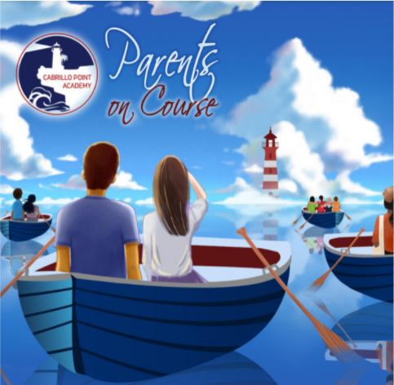
Parent on Course is comprised of workshops offered by outside guest speakers as well as the incredible talent and wealth of knowledge we have here on staff. Each workshop will be designed to support our parents with some facet of their child’s education and overall well-being. The workshops will address academics, curriculum, social-emotional health, behavior, technology, school knowledge, and many other topics that will engage parents and support them in navigating the educational journey with their child/ren. Please visit our Parents on Course webpage for a monthly calendar of events and Zoom Links to Access!

