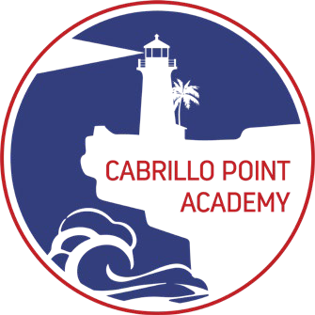
Cabrillo Point Academy
4612 Dehesa Road, El Cajon, CA 92019 Ph (619) 404-3190 | Fax (619) 749-1792

AGENDA
Cabrillo Point Academy DELAC Special Agenda
April 14, 2021; 5:00 pm

Item |  | Presenter
Welcome and Call to Order |  | Jennifer Carrete
II. New Business
- Review of LCAP Addendum Rupi Boyd
- Review of Title 1 Parent Involvement Policy
III. Adjournment |  | Jennifer Carrete

